

**Digital Portfolio**

STUDENT NAME: srija E

REGISTER NO AND NMID: 2422k0 381/FCC2BBB27B2E27BA3214

ED3829F1DBE1

DEPARTMENT: B.Sc.Computer Science.

COLLEGE: COLLEGE/ UNIVERSITY: Adithya College of Arts And   
Science/Bharathiyar University.

1



**PROJECT TITLE**

Digital portfolio

2



**AGENDA**

1.Problem Statement

2.Project Overview

3.End Users

4.Tools and Technologies   
5.Portfolio design and Layout   
6.Features and Functionality

7.Results and Screenshots   
8.Conclusion   
9.Github Link

3/21/2024 **Annual Review**  3



**PROBLEM STATEMENT**

• In today's digital era, traditional resume   
alone are not enough to showcase skills   
and projects effectively.

• Many students and professionals lack a   
 structured online presence to highlight

their work.

• A Digital portfolio provides an   
interactive and accessible platform to   
present achievements, skills,   
and experiences.

4



**PROJECT OVERVIEW**

• A Detailed summary of my   
 project.

• It contains About us, Project,   
 Skill, Contact.

• Main idea: Showcase

Personal Achievements,   
skills, Certifications.

5



**WHO ARE THE END USERS?**

• Students.

• Job seekers.

• Beginners.

• Professionals.

6



**TOOLS AND TECHNIQUES**

• HTML - Structure the

webpage.

• CSS - Style the page.

• JS - Develop interactivity   
 between user & developer.

• Use visual studio code or

codepen for   
coding.Hosting   
paltform on github.

7



**POTFOLIO DESIGN AND LAYOUT**

Section Include:

• Home/About us

• Projects

• Skills

• Contacts

• Responsive   
 Layout(mobile,desktop view)

8



**FEATURES AND FUNCTIONALITY**

• Navigation with smooth   
 scrolling.

• Project showcase with   
 images.

• Interactive Elements.

• Contact form.

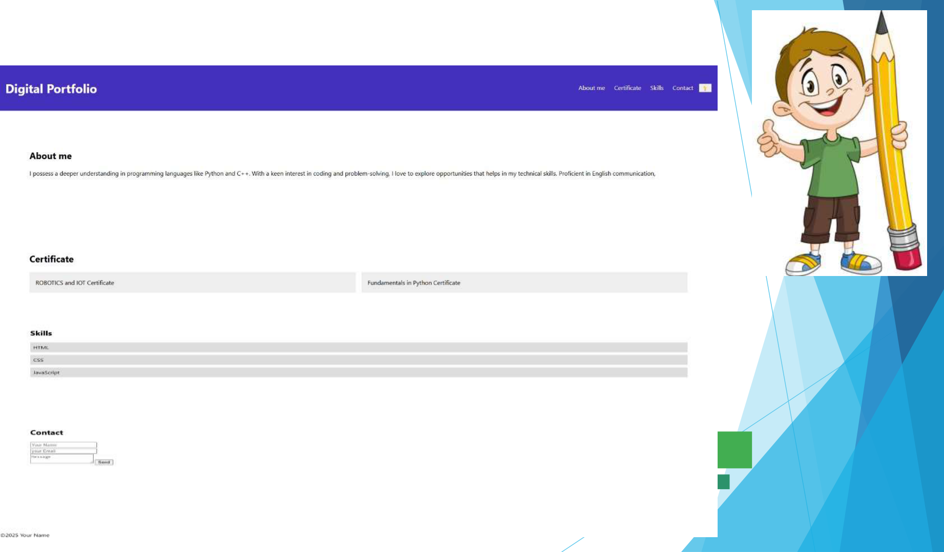

**RESULTS AND SCREENSHOTS**

3/21/2024 **Annual Review**  10

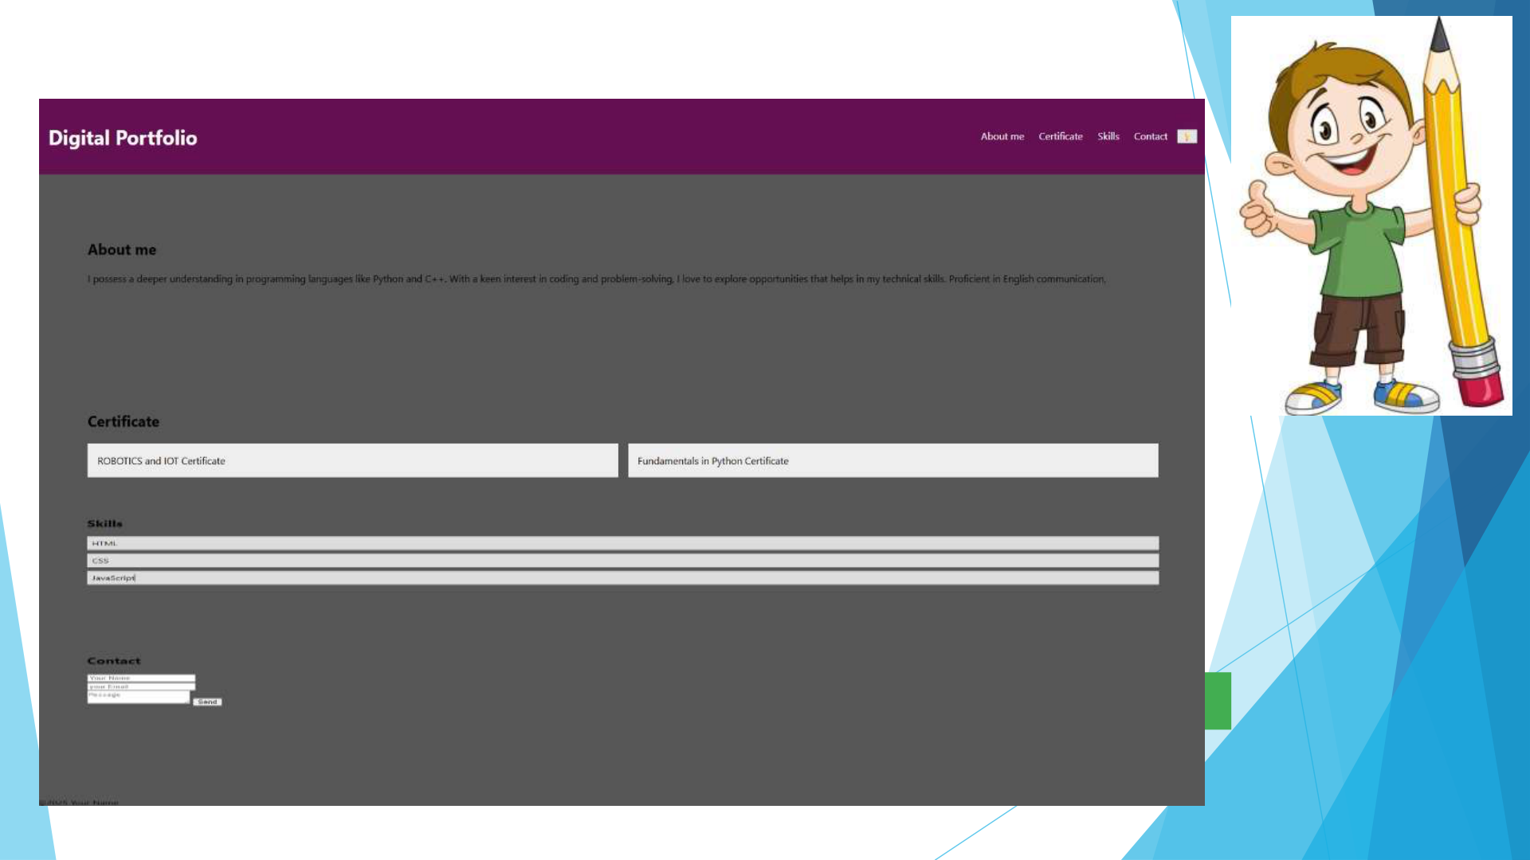

**RESULTS AND SCREENSHOTS:**

3/21/2024 **Annual Review**  11



**CONCLUSION**

It will help you to develop   
your personal portfolio easily.   
It defintely helps the people to   
introduced them formally to   
the professionals.

12